Appendix S4

We ran three chains for each parameter and ran each chain for 100,000 iterations, with a burn-in period of 10,000 iterations, and thinned by 50. We evaluated convergence of chains by visual inspecting trace plots, and using the diagnostics Gelman-Rubin statistic, where Rhat < 1.1 (Brooks & Gelman 1998). We also assessed model fits using posterior predictive checks and the χ2 fit statistic to determine if the likelihood and deterministic models are reasonable approximations of the ecological process (Gelman *et al.* 2013). A value close to 0.5 indicates adequate model fit and extreme values close to either 0 or 1 indicate poor model fit. We fit the model with a variety of priors to determine if this affected posterior estimates, and we found that it did not (Fig. S1). We found that the full model and the null model adequately fit the data (Fig. S2, S3, S4, S5), and that the random effect term in the random effects model did not show large variation in transmission probability among sites (Fig. S6).

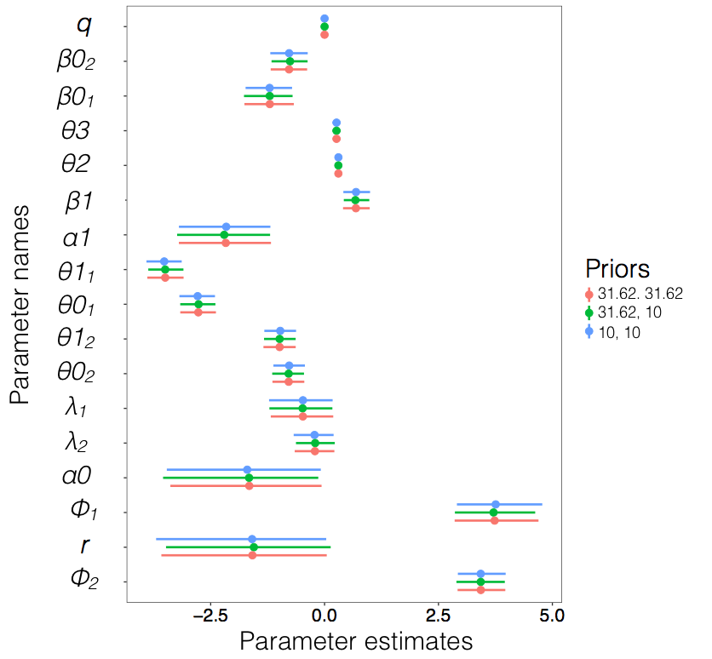

Figure S1. We ran the model three times with different combinations of priors to evaluate the influence of priors on parameter posterior distributions. We used priors centered on zero, and we varied the standard deviation coefficient (i.e., 31.62 or 10). The first value in the figure legend represents the standard deviation indicated for the gains (*β0i, β1*) parameters and the second value represents the standard deviation indicated for the mean host abundance (*λi*) parameters.

Macintosh HD:Users:Cici:GitHub:2010to2014ElCope:Figures:Mode fit.pdf

Figure S2. Bayesian posterior predictive check for the (A) infected and (B) uninfected models, where values near 0.5 suggest good model fit. Extreme values (i.e., ≤ 0.05 or ≥ 0.95) suggest poor model fit to data.

Macintosh HD:Users:Cici:GitHub:2010to2014ElCope:Figures:Season mod fit.pdf

Figure S3. Bayesian posterior predictive check for the infected model during (A) wet 2010, (B) wet 2011, (C) wet 2012, (D) dry 2013, (E) wet 2013, and (F) dry 2014.

Figure S9. Bayesian posterior predictive check for the (A) infected and (B) uninfected null model, where values near 0.5 suggest good model fit. Extreme values (i.e., ≤ 0.05 or ≥ 0.95) suggest poor model fit to data.

Macintosh HD:Users:Cici:GitHub:2010to2014ElCope:Figures:Null model fit.pdf

Figure S4. Bayesian posterior predictive check for the null model (A) infected and (B) uninfected models, where values near 0.5 suggest good model fit. Extreme values (i.e., ≤ 0.05 or ≥ 0.95) suggest poor model fit to data.

Macintosh HD:Users:Cici:GitHub:2010to2014ElCope:Figures:Null model fit Infected.pdfFigure S5. Bayesian posterior predictive check for the infected null model during (A) wet 2010, (B) wet 2011, (C) wet 2012, (D) dry 2013, (E) wet 2013, and (F) dry 2014.

Macintosh HD:Users:Cici:GitHub:2010to2014ElCope:Figures:Random effect plot.pdf

Figure S6. The mean and 95% credible interval of the random effect term applied to each site-year combination on the transmission risk model (*c*) on the logit scale.

References

Brooks, S.P. & Gelman, A. (1998) General methods for monitoring convergence of iterative simulations. *Journal of Computational and Graphical Statistics*, 7, 434–455.

Gelman, A., Carlin, J. B., Stern, H. S., Dunson, D. B., Vehtari, A., & Rubin, D. B. (2013) Bayesian data analysis. CRC Press, Boca Raton, Florida, USA.